**Abstract:**

A MOSFET transistor is a three terminal semiconductor device in which, current flowing from the drain to source terminals, is controlled by the voltage on the gate terminal and it can be used as an amplifier and a switch. This experiment discusses the properties of the common source MOSFET amplifier. The voltage gain, input and output voltages will be investigated both theoretically and experimentally.

**Introduction:**

The most common transistor types are the Metal Oxide Semiconductor Field Effect Transistors (MOSFETs) and the Bipolar Junction Transistors (BJT). BJTs based circuits dominated the electronics market in the 1960's and 1970's. Nowadays most electronic circuits, particularly integrated circuits (ICs), are made of MOSFETs. The BJTs are mainly used for specific applications like analog circuits (e.g. amplifiers), high-speed circuits or power electronics. There are two main differences between BJTs and FETs. The first is that FETs are charge-controlled devices while BJTs are current controlled devices. The second difference is that the input impedance of the FETs is very high while that of BJT is relatively low. As for the FET transistors, there are two main types: the junction field effect transistor (JFET) and the metal oxide semiconductor field effect transistor (MOSFET). The power dissipation of a JFET is high in comparison to MOSFETs. Therefore, JFETs are less important if it comes to the realization of ICs, where transistors are densely packed. The power dissipation of a JFET based circuit would be simply too high. MOSFETs became the most popular field effect device in the 1980's.

The objective of this experiment are

1. to become familiar and study the characteristics of MOSFET common source (CS) amplifier.
2. to determine the voltage gain, input and output voltages by using DC and AC analysis.
3. to investigate the input and output waveforms of CS amplifier circuit.

**Theory and Methodology:** The MOSFET structure has become the most important device structure in the electronics industry. It dominates the integrated circuit technology in Very Large Scale Integrated (VLSI) digital circuits based on n-channel MOSFETs and Complementary n-channel and p-channel MOSFETs (CMOS). The technical importance of the MOSFET results from its low power consumption, simple geometry, and small size, resulting in very high packing densities and compatibility with VLSI manufacturing technology.

Two of the most popular configurations of small-signal MOSFET amplifiers are the common source and common drain configurations. The common source circuit is shown in Figure 1. The common sources, like all MOSFET amplifiers, have the characteristic of high input impedance. High input impedance is desirable to keep the amplifier from loading the signal source. This high input impedance is controlled by the bias resistor RG (or bias resistors RG1 and RG2). Normally the value of the bias resistor(s) is chosen as high as possible. However too big a value can cause a significant voltage drop due to the gate leakage current. A large voltage drop is undesirable because it can disturb the bias point. For amplifier operation the MOSFET should be biased in the saturated region of the characteristics.

The common source (CS) and common drain (CD) MOSFET amplifiers can be compared to the common emitter (CE) and common collector (CC) BJT amplifiers respectively. Like the CE amplifier, the CS amplifier has a negative voltage gain and an output impedance approximately equal to the drain resistor (collector resistor for the CE amplifier). The CD amplifier is comparable to the CC amplifier with the characteristics of high input impedance, low output impedance, and less than unity voltage gain.

**Apparatus:**

1. Resistors: 5.6 kΩ, 10 kΩ, 100 kΩ, 1MΩ.
2. MOSFET: n-channel MOSFET (IRF540 or IRF640).
3. Capacitor: 22 μF (2).
4. Connecting wires.
5. Trainer Board.
6. Multimeter.
7. DC power supply.
8. Power cables and probes.
9. Oscilloscope.
10. Function generator.

**Circuit diagram:**

**R**

**D**

**5**

**.**

**6**

**k**

**Ω**

**1**

**.**

**0**

**M**

**Ω**

**R**

**G**

**R**

**L**

**10**

**k**

**Ω**

**C**

**1**

**22**

**µF**

**V**

**in**

**V**

**DD**

**10**

**V**

**C**

**2**

**22**

**µF**

**V**

**0**

**20**

**mV**

**10**

**kHz**

**G**

**S**

**D**

**Figure 1: MOSFET Common Source Amplifier**

**1**

**0**

**mV**

**Experimental Data Table:**

**Table-1 (DC Analysis)**

|  |  |  |  |  |  |  |  |  |  |
| --- | --- | --- | --- | --- | --- | --- | --- | --- | --- |
| **VCC** |  |  | **VD** |  | **VS** | |  | **VG** | **ID** |
| **10 v** |  | **3.34 v** |  |  | **0** | |  | **3.32 v** | **1.30 mA** |
|  |  |  |  | **Table-2 (AC Analysis)** | | | |  |  |
| **Frequency** |  | **Vin** |  | **Max. Vin** | | **V0** | | **AV** | **Phase Difference** |
| **10 kHz** | **20.41** | | | **20.41** | | **1.27** | | **0.062224** | **176.7 º** |

**Simulation:**

**DC ANALYSIS:**

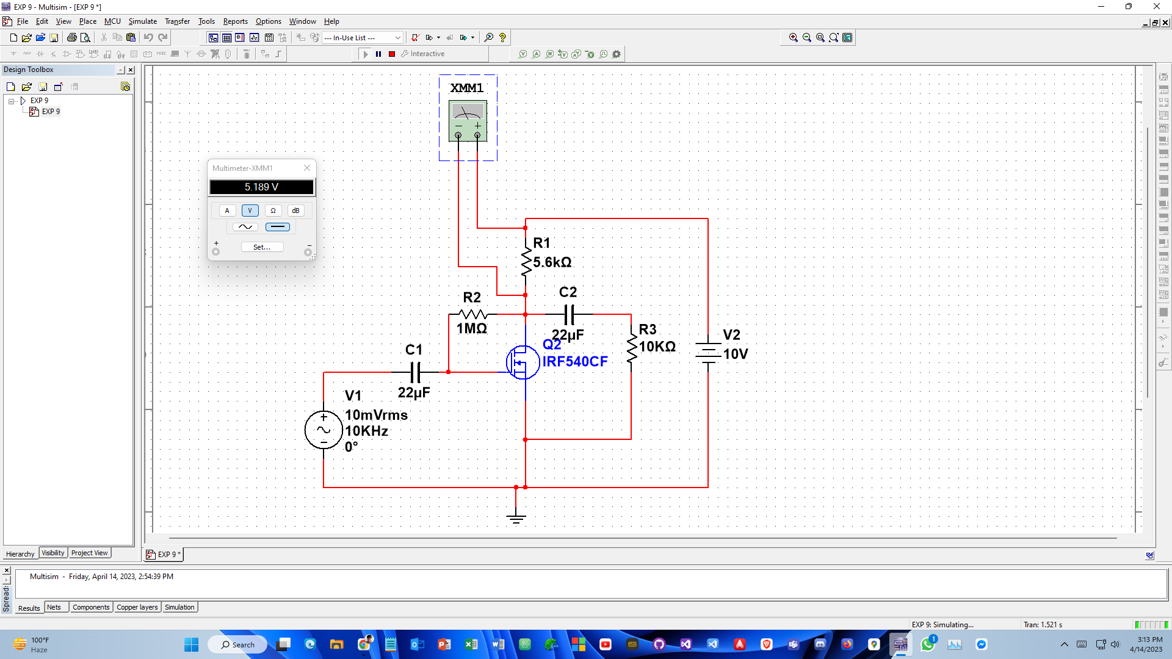

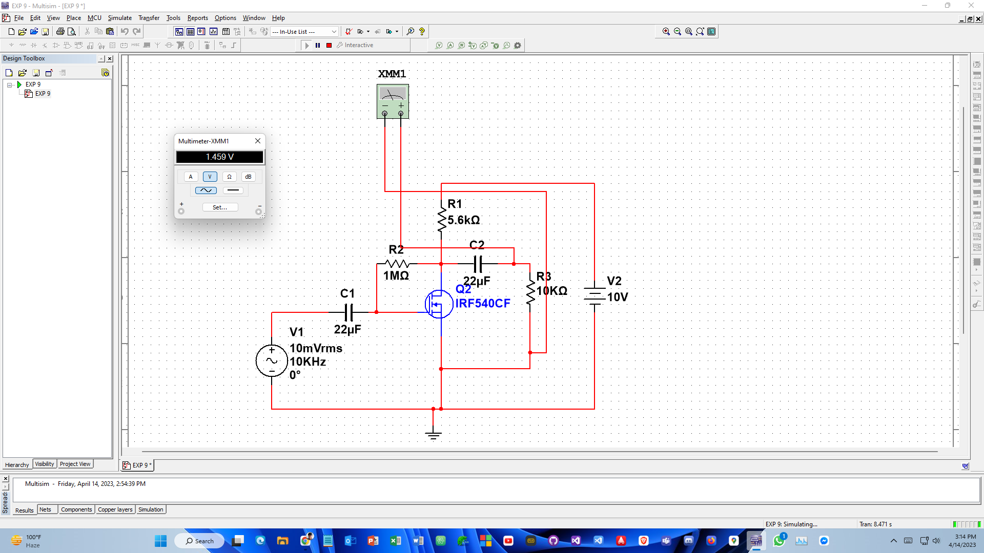

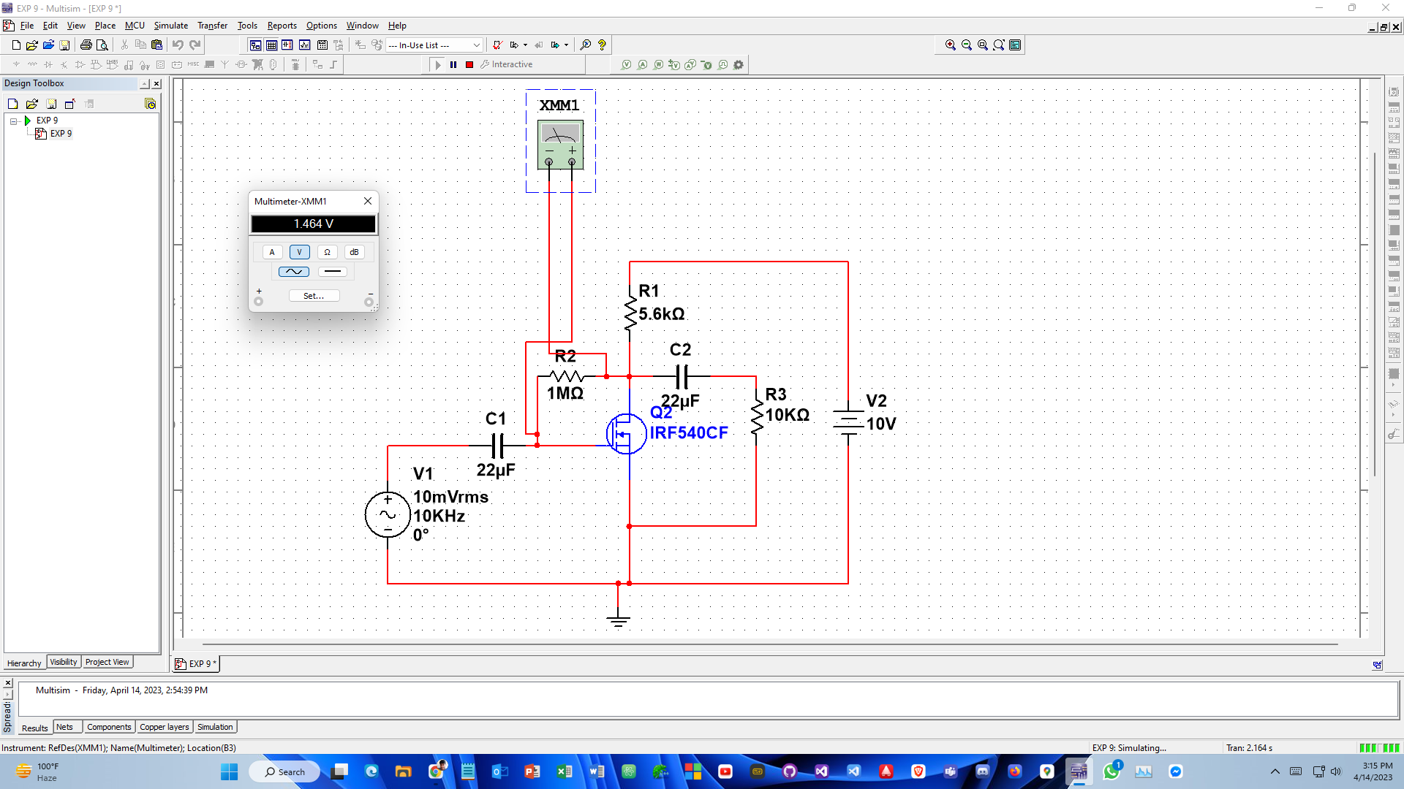

**AC analysis:**

